Assignment 5: Hough Transform

In this Assignment, I implemented the Hough transform in MATLAB. Taking an input image, I used the built-in edge() function to get the canny edge detected version of the image to use as input for the transform. Using each edge pixel, I determined the polar coordinates of every cartesian line that it could fall on, and using those values, created a polar plot of the Hough space. To find the strongest lines, I used thresholding to fine the local maxima and converted back to cartesian lines and plotted over the original image.

I processed the edge image by first getting all the edge pixels coordinates and converting those to polar coordinates to get the theta values using the equation \rho = x \cos \theta + y \sin \theta. I generated a matrix of size 2x181 with the first row as cosines of theta values, and row two as sines of the theta values. Using the x, y coordinates from the edge map, I created an Nx2 matrix with x values in the first column and y values in the second. Multiplying matrix two by matrix one gave an output of Nx181 rho values where N is the number of edge pixels. Using the column number and rho values, I incremented an accumulator matrix of size 2Dx181, where D is the image diagonal, at the corresponding pixels.

Using the accumulator matrix, I found the local maxima using a threshold value equal to a percentage of the global maximum value in the accumulator. Using that small number of points, I converted back to cartesian coordinates and plotted over the original image.

The main issue I had was not getting the edges to plot back into the main image and overlay any visible edges. I had a lot of lines plotting radially from the upper left corner on my first attempts and plotting in random places off the image on successive changes. I have included examples of what I mean at the end of the images section.

Youtube Link: I will add to comment section on the submission.

Building:

Original Edge Map Hough Space Final

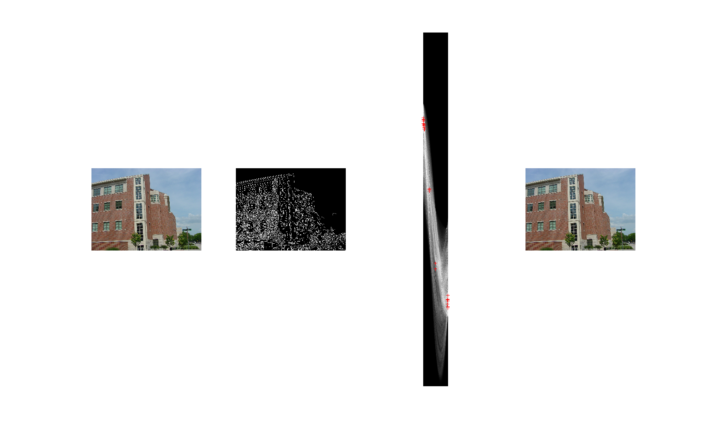

Campus:

Original Edge Map Hough Space Final

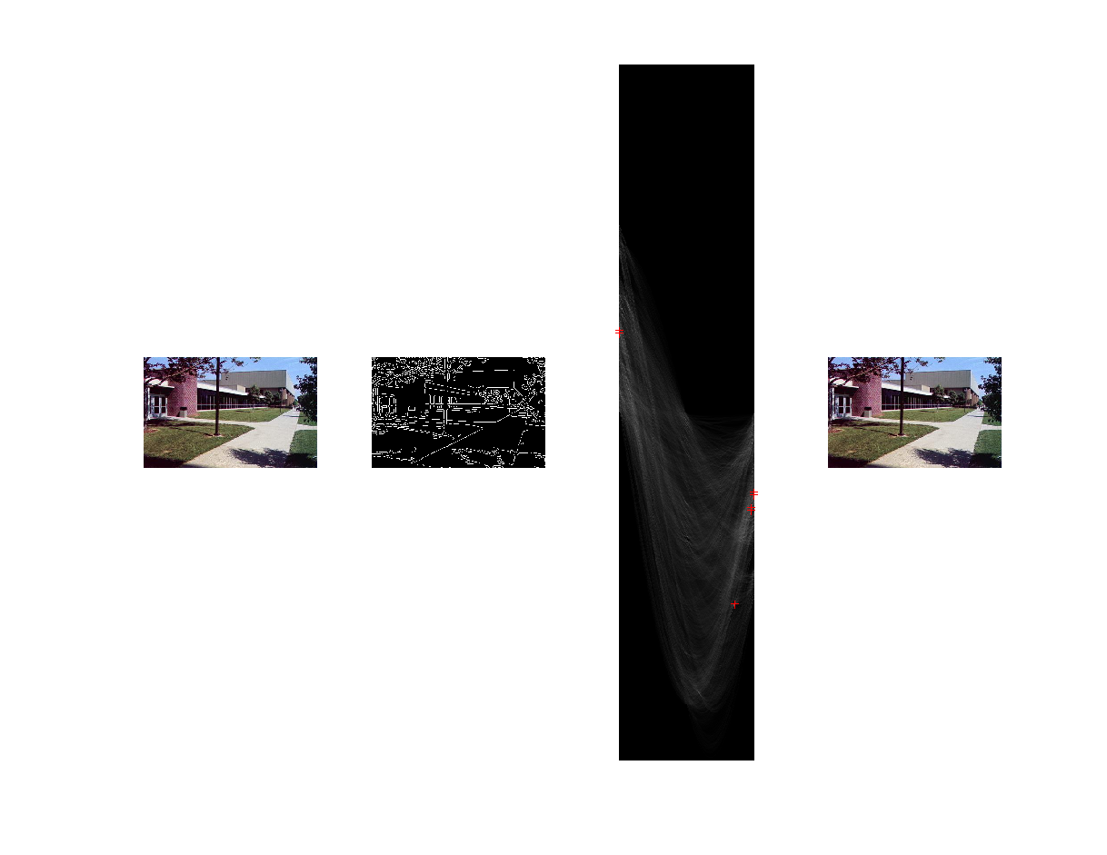

Castle:

Original Edge Map Hough Space Final

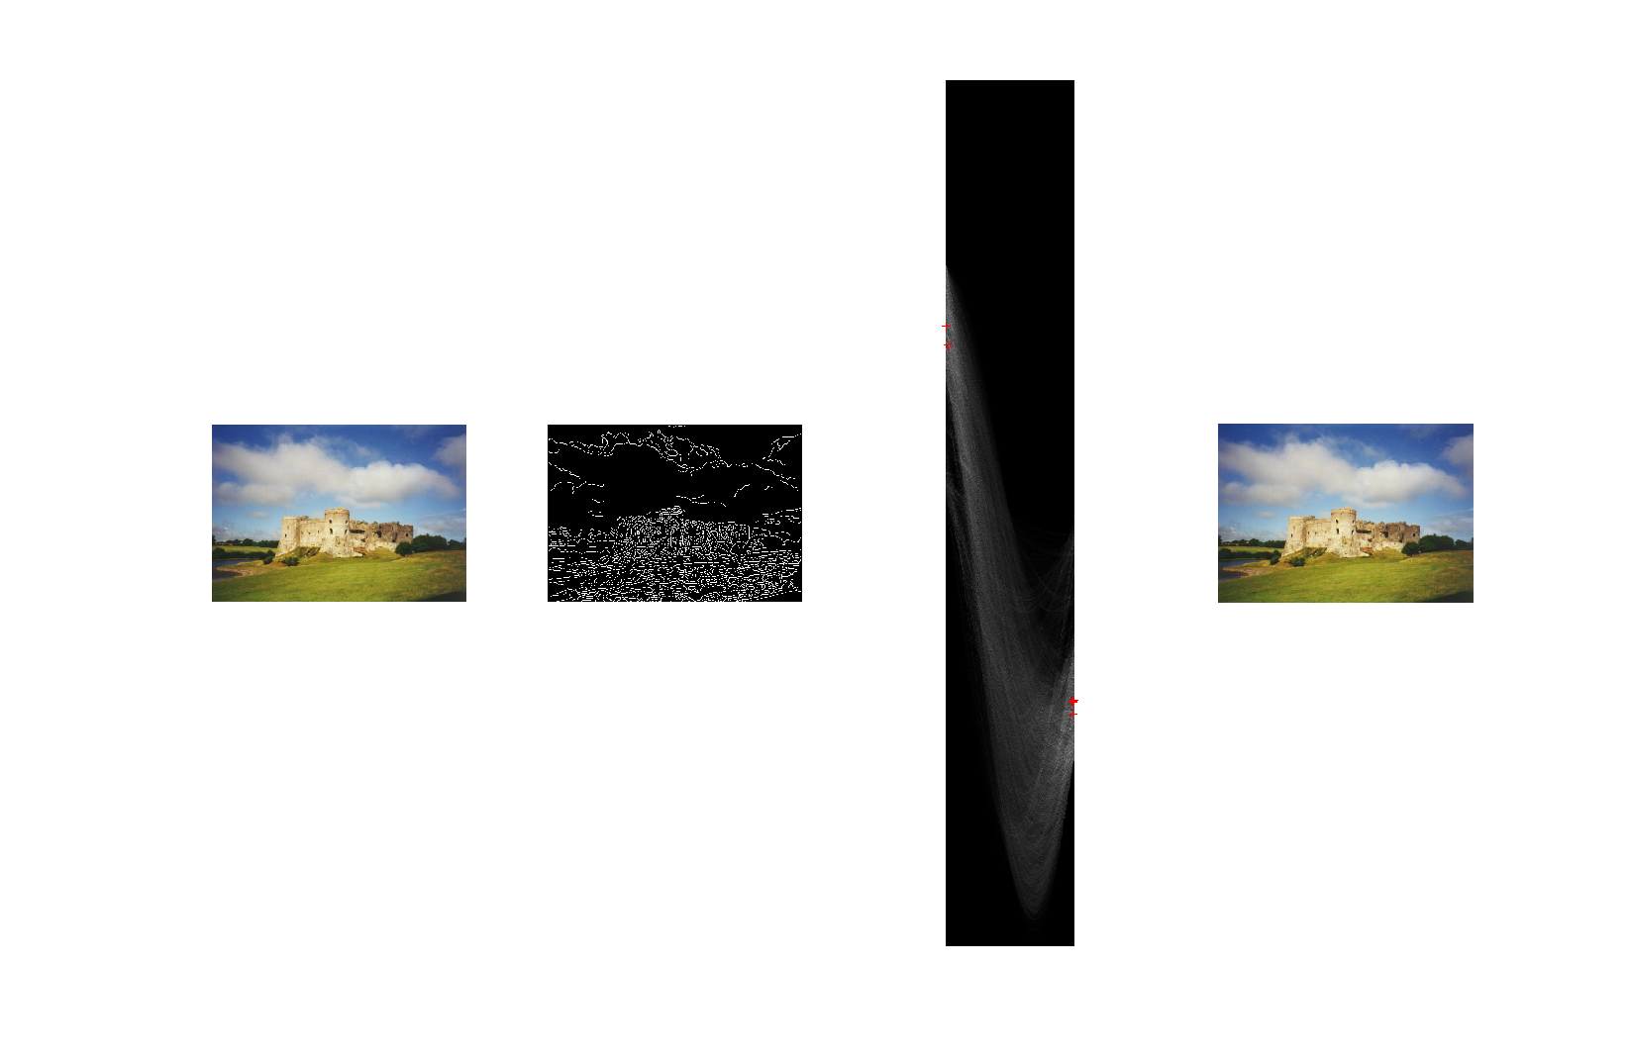

Road:

Original Edge Map Hough Space Final

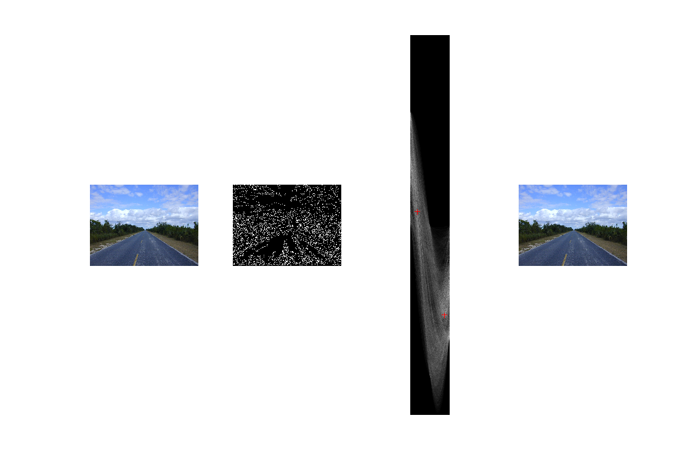

Rock:

Original Edge Map Hough Space Final

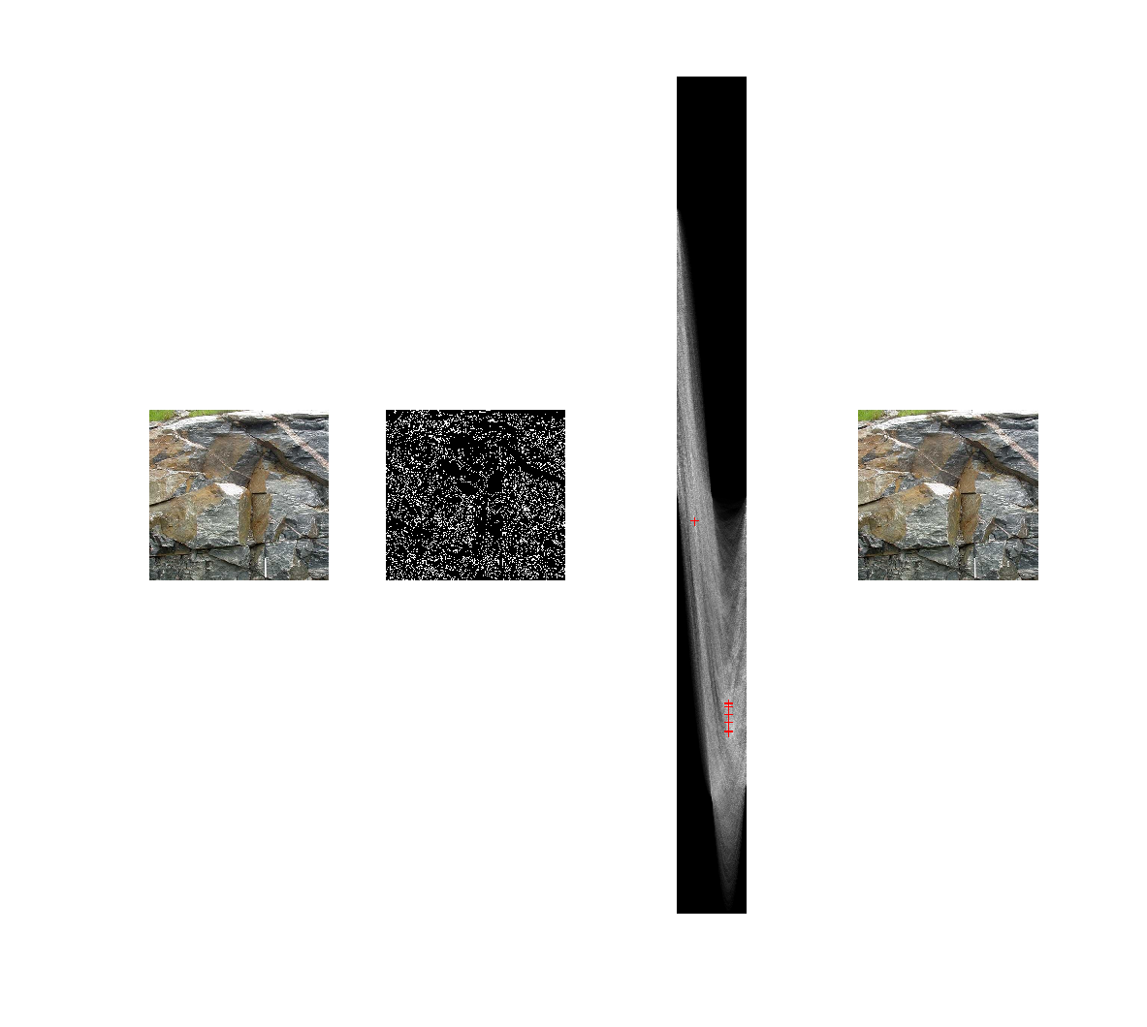

Roof-top:

Original Edge Map Hough Space Final

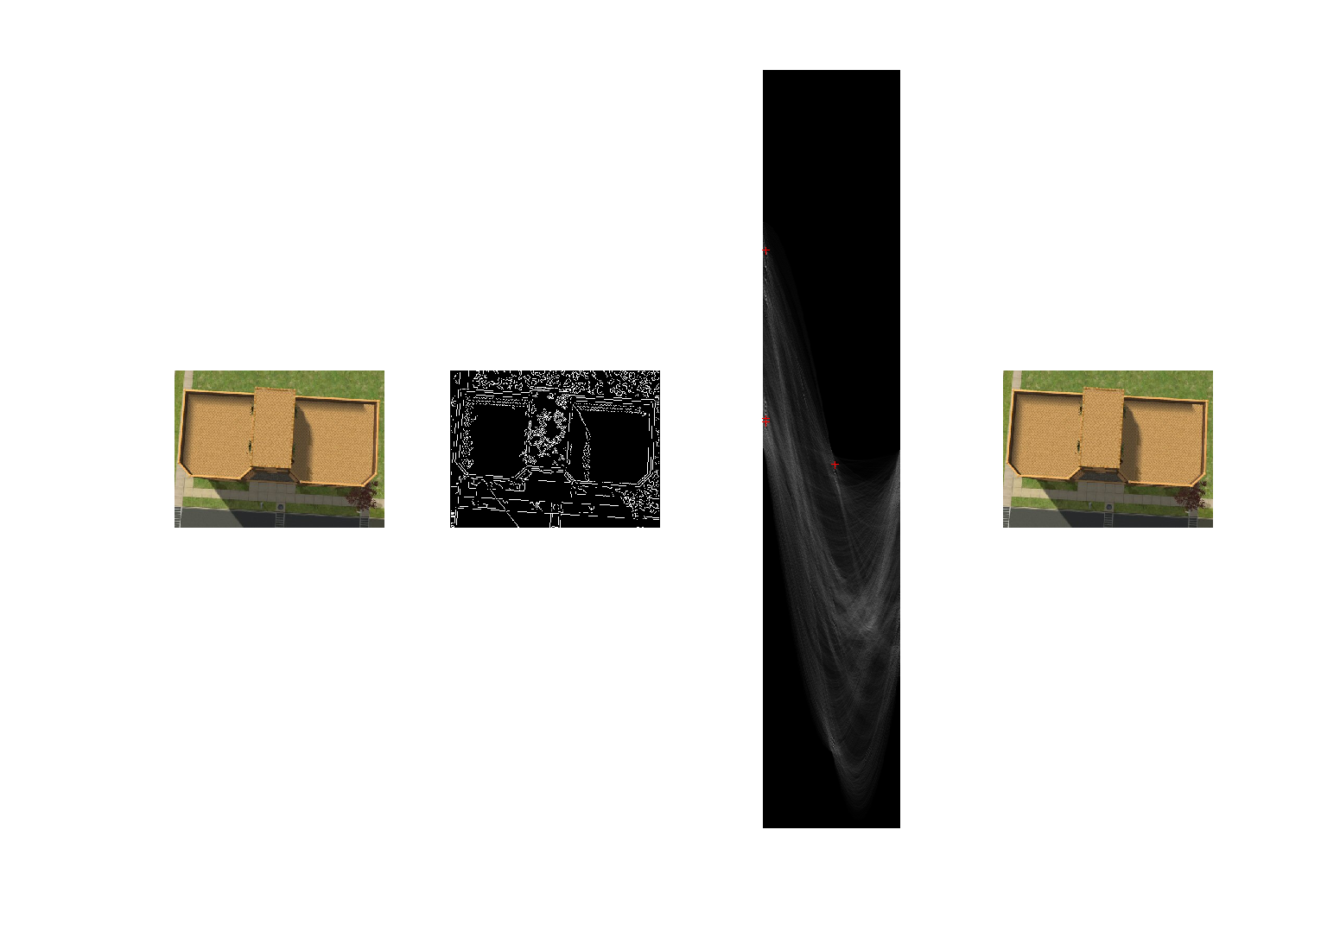

Output Error Examples:

